A

PROJECT REPORT

**On**

# Block Smasher Game

*Submitted in partial fulfillment of the requirements for the award of the degrees*

***of***

##### BACHELOR OF TECHNOLOGY in INFORMATION TECHNOLOGY

*Submitted by:*

**Aastha Dewangan (300103321020)**

**Khushi Dewangan (300103321041)**

**Abhishek Dewangan (300103322301)**

*Guided by:*

**Dr. Ani Thomas (Head of Department)**



### BHILAI INSTITUTE OF TECHNOLOGY DURG

**DEPARTMENT OF INFORMATION TECHNOLOGY**

**UGC Autonomous Institution**

**(Affiliated to CSVTU, Approved by AICTE, NBA &NAAC ACCREDIATED) DURG– 491001, CHHATTISGARH, INDIA** [**www.bitdurg.ac.in**](http://www.bitdurg.ac.in/)

**SESSION: 2023-24**

## CANDIDATE’S DECLARATION

We hereby declare that the project entitled **“Block Smasher Game”** submitted in partial fulfillment for the award of the degree of Bachelor of Technology in Information Technology completed under the supervision of **Dr. Ani Thomas, Head of Department, Information Technology,** BIT DURG is an authentic work.

Further, I/we declare that I/we have not submitted this work for the award of any other degree elsewhere.

(Signature of the Candidate)

Name of the candidate: Aastha Dewangan

(Signature of the Candidate)

Name of the candidate: Khushi Dewangan

(Signature of the Candidate) Name of the candidate: Abhishek Dewangan

## CERTIFICATE

This is to certify that the report of the minor project submitted is an outcome of the project work entitled **Block Smasher Game** carried out by **Aastha Dewangan (300103321020) Enrollment No. CA6662, Khushi Dewangan (300103321041) Enrollment No. CB4387, Abhishek Dewangan (300103322301) Enrollment No. BH8068,** under my guidance and supervision for the award of Degree in Bachelor of Engineering in Information Technology of Bhilai Institute of Technology, Durg (C.G) , India.

(Signature of the Guide) Name of Guide: Dr. Ani Thomas

Designation: Head of Department Department: Information Technology Name of the Institute: B.I.T. Durg

The project work as mentioned above is hereby being recommended and forwarded for examination and evaluation.

(Signature of Head of Dept.)

## CERTIFICATE BY THE EXAMINERS

This is to certify that the project work entitled **Block Smasher Game.** Submitted by **Aastha Dewangan (300103321020) Enrollment No. CA6662, Khushi Dewangan (300103321041) Enrollment No. CB4387, Abhishek Dewangan (300103322301) Enrollment No. BH8068** has been examined by the undersigned as a part of the examination for the award of Bachelor of Technology degree in Information Technology.

Internal Examiner External Examiner

### ACKNOWLEDGEMENT

We wish to acknowledge with a deep sense of hearty gratitude and indebtedness to Mr. Amrendra Kumar Singh, Information Technology, who gave us this opportunity to experience project work & his valuable suggestion during this project have been invaluable. We take this opportunity to voice & record our sincerest gratefulness towards our esteem Supervisor **Dr. Ani Thomas** mam under whose able guidance the project work has been brought to completion. Our heart leaps up in thankfulness for her benevolence & time to time help, valuable suggestions, constructive criticism & active interest in the successful completion of this project work.

We are also thankful to all our honorable Principal, Head of Department and teachers of the Information Technology Department and our parents whose valuable support helped us and kept us motivated all through.

**Aastha Dewangan Khushi Dewangan Abhishek Dewangan** B.Tech. V Sem

Department of Information Technology

BIT DURG

|  |  |  |  |
| --- | --- | --- | --- |
|  | | Table of Contents |  |
| Abstract |  |  | 7 |
| CHAPTER |  | TITLE | PAGE NO. |
| I |  | Introduction | 8 |
| II |  | Literature Review | 9 |
|  | 2.1 | Overviews | 9 |
|  | 2.2 | Objective and scopes | 10 |
| III |  | Problem Identification | 12 |
|  | 3.1 | Problem Statement | 12 |
|  | 3.2 | Hardware and Software Requirements | 12-14 |
| IV |  | Methodology | 15 |
|  | 4.1 | Steps | 15-16 |
|  | 4.2 | DFD | 17 |
|  | 4.3 | Code | 19-24 |
|  | 4.4 | Integration of various modules | 25-26 |

|  |  |  |  |
| --- | --- | --- | --- |
| V |  | Result & Discussion | 27 -29 |
| VI |  | Conclusion & scope of further work | 30 |
|  | 6.1 | Conclusion | 31 |

## ABSTRACT

This report provides a comprehensive overview of the development process of a Brick Smasher game using Java. The report covers various aspects of the development process, including game components, game logic, user interface, game loop, additional features, challenges and considerations, testing and debugging, deployment, post-development activities, open source and collaboration, and future enhancements and sequels. The report emphasizes the importance of careful consideration of each stage of the development process, engagement with players and the community, and continuous improvement to create a successful and enjoyable game. The report also highlights the opportunities for learning, creativity, and collaboration that arise during game development and provides insights into building a successful and sustainable game development career.

## CHAPTER Ⅰ INTRODUCTION

The Brick Breaker game is a classic and popular arcade-style game that has entertained players for decades. In this game, players control a paddle at the bottom of the screen and use it to bounce a ball towards an arrangement of bricks at the top of the screen. The goal is to break all the bricks by hitting them with the ball while preventing the ball from falling below the paddle.

This report outlines the process of implementing a simple yet engaging version of the Brick Breaker game using the Java programming language. Java is a versatile and widely-used programming language that is well-suited for developing games due to its object-oriented design, built-in graphics libraries, and cross-platform compatibility.

The report covers various aspects of game development, including the design and implementation of game components, handling user input and game logic, creating a user interface, and managing the game loop. Additionally, the report discusses challenges and considerations in game development, testing and debugging, deployment options, and ways to enhance and extend the game.

Overall, the development of a Brick Breaker game in Java provides a valuable opportunity for developers to practice and apply their programming skills, learn about game development concepts and techniques, and create an entertaining and interactive gaming experience for players.

## CHAPTER Ⅱ

**LITERATURE REVIEW**

A literature review of a block smasher game should cover various aspects, including design, user experience, cognitive and motor skill development, educational applications, psychological and behavioral impacts, platform and technology, social and multiplayer features, user feedback, cultural and societal influences, accessibility, and emerging trends. Analysing research and studies on these topics can provide insights into the game's development, impact, and user engagement.

#### Overview:

In a block smasher game, the player's main task is to use the paddle to keep a bouncing ball in play. By strategically directing the ball toward the bricks or blocks positioned at the top of the screen, the player aims to break as many of them as possible. These bricks come in different colors, shapes, and patterns, and some might require multiple hits to be destroyed.

As the game progresses, it often becomes more challenging with complex brick arrangements and the introduction of special bricks that can release power-ups, bonuses, or extra balls when hit. Power-ups can grant the player advantages, like a larger paddle, increased ball speed, or the ability to shoot projectiles.

The player's score increases with each brick they destroy, and achieving high scores is a central goal. The game continues until the player loses all their lives, which happens when the ball falls below the paddle a certain number of times.

Block smasher games are known for their accessibility and addictive gameplay, making them appealing to players of all skill levels. They have a long history in the world of video games and have been adapted to various platforms, from classic arcade cabinets to modern mobile devices.

#### Objectives:

Understand Game Design Principles: To analyze the fundamental design principles that underlie block smasher games, including level design, ball physics, power-ups, and scoring mechanisms. Examine User Experience: To explore the player experience in block smasher games, focusing on aspects like engagement, enjoyment, and immersion, and how these factors are influenced by game design.

Assess Cognitive and Motor Skill Development: To investigate how block smasher games impact cognitive skills (e.g., problem-solving, spatial reasoning) and motor skills (e.g., hand-eye coordination) through gameplay. Explore Educational Applications: To review how block smasher games are used in educational settings, such as teaching physics concepts or improving problem-solving skills in a learning environment.

Assess Technological Impact: To evaluate how the choice of gaming platform (e.g., mobile, console, PC) and emerging technologies (e.g., VR/AR) affect the gameplay and user experience of block smasher games. Examine Social and Multiplayer Aspects: To investigate the social and multiplayer features of block smasher games, such as leaderboards, cooperative or competitive gameplay, and their impact on player engagement.

Analyze User Feedback and Reviews: To study user reviews, feedback, and comments on popular block smasher games to gain insights into player preferences, criticisms, and suggestions for improvement.

#### Scope:

* Analysis of design principles, gameplay mechanics, and player engagement in block smasher games.
* Examination of the impact of block smasher games on cognitive and motor skill development.
* Review of educational applications and the use of block smasher games in teaching.
* Assessment of psychological and behavioral effects, including player motivation and addiction.
* Comparative analysis with other video game genres to understand differences in player experiences.
* Evaluation of the technological impact, including gaming platform and emerging technologies.

.

**CHAPTER Ⅲ**

**PROBLEM IDENTIFICATION**

**Problem Statement**

* Design and implement a block smasher game where the player controls a paddle at the bottom of the screen to bounce a ball and break a grid of blocks located at the top of the screen.
* The objective is to clear all the blocks from the screen by bouncing the ball off the paddle and into the blocks.
* The project should:
  1. Display blocks and disappear after hitting the ball.
  2. Small platform(paddle) moving left and right.
  3. The ball must bounce after hitting block, walls and paddle at the bottom.
  4. Score display.

The ultimate goal is to achieve the highest score possible.

## HARDWARE AND SOFTWARE REQUIREMENTS

For the successful development and deployment of a block smasher game project built on Java, the following hardware and software requirements need to be considered:

##### Hardware Requirements:

**Operating System:** The development machine should have a compatible operating system. Java is platform independent, but the development environment may have OS-specific requirements.

**Processor:** A multi-core processor is recommended to ensure efficient development and usage of the password manager.

**Memory (RAM):** A minimum of 4GB of RAM is recommended for smooth development and testing. More RAM may be required for larger-scale projects.

**Storage:** Adequate storage space is needed for the development environment, source code, and any associated files. At least 100GB of storage is recommended.

**Display:** A standard monitor with a resolution of 1280x1024 or higher is advisable for efficient coding and testing.

##### Software Requirements:

**Game Development Environment:**

**Game Engine:** You will need a game engine or development framework for creating your block smasher game. Popular game engines include Unity, Unreal Engine, Godot, or GameMaker Studio. The choice depends on your preferred programming language, platform, and features.

**Integrated Development Environment (IDE):** An IDE or code editor for writing and managing your game's source code. The choice of IDE may depend on the game engine you select.

**Graphics and Animation Software**: Graphic design software such as Adobe Photoshop, GIMP, or pixel art tools for creating game assets, including sprites, backgrounds, and animation.

##### Overview

The block smasher game follows a client-server architecture, where the client is a Java Swing-based GUI application, and the server is a MySQL database for score storage.

##### Class Diagram

A class diagram illustrates the structure of your game's classes and their relationships. Classes may include Player, Game, Ball, Paddle, Brick, PowerUp, and more. These classes interact to create the game's behaviour.

##### Database Schema

If your game involves data storage, the database schema could include tables for Players, Scores, Levels, and other game-related entities. Fields would include player names, scores, game progress, and timestamps.

##### Technologies Used: Programming Languages

Java is a versatile, platform-independent programming language known for its security and portability. Developed by Sun Microsystems, it employs a "write once, run anywhere" philosophy through the Java Virtual Machine (JVM). With strong community support and a rich library, Java is widely used in web, mobile, and enterprise application development.

**Libraries and Frameworks-**Java Swing for GUI

Java Swing is a versatile and widely used library for developing graphical user interfaces (GUIs) in Java applications, including games. Swing offers a rich set of features and components that are invaluable for creating the user interface of a block smasher game. Its comprehensive collection of GUI components, including buttons, labels, text fields, and more, makes it easy to design interactive game menus, settings screens, and score displays. Swing provides layout managers to arrange and control the positioning of these components within windows or panels, enabling organized and responsive user interfaces.

**IDE-**Intellij IDEA

IntelliJ IDEA is an integrated development environment written in Java for developing computer software written in Java, Kotlin, Groovy, and other JVM-based languages. It is developed by JetBrains and is available as an Apache 2 Licensed community edition, and in a proprietary commercial edition.

## CHAPTER Ⅳ

**METHODOLOGY**

The Java-based Block smasher project follows a structured methodology: planning, design, implementation, testing, and deployment. The user-friendly GUI enhances the user experience, and thorough documentation aids understanding. Ongoing maintenance and future development remain integral for long-term project success. Following steps are followed for the development of this projects

##### Steps:

Step 1: Project Planning and Requirements Gathering Define Project Objectives and Requirements.

* Determine Feature Set.
* Plan the Application Architecture.
* Decide on GUI (optional).

Step 2: Set Up Your Development Environment - Install JDK.

* Install Integrated Development Environment (IDE) (e.g., VS Code).
* Configure IDE and project settings.

Step 3: Concept and Planning –

* Idea Generation: Begin by brainstorming and conceptualizing the core gameplay mechanics and objectives of your block smasher game.
* Market Research: Analyze existing block smasher games to understand the competition and identify opportunities for innovation.
* Game Design Document (GDD): Create a comprehensive GDD that outlines the game concept, story (if applicable), gameplay mechanics, levels, characters, and objectives.
* Prototyping: Develop a simple prototype or minimum viable product (MVP) to test the core game mechanics and gather initial feedback.

Step 4: Development -

* Choose Development Tools: Select a suitable game engine, programming language, and development environment that align with your project's requirements and your team's expertise.
* Create Game Assets: Design and create game assets, including graphics (sprites, backgrounds), audio (sound effects, music), and animations.
* Game Programming: Implement the game logic, including ball movement, paddle control, collision detection, scoring, and level progression. Code the user interface, menus, and any additional features.
* Graphics and Animation: Integrate graphical assets and animations into the game engine.
* Testing and Debugging: Continuously test the game to identify and fix bugs. Ensure that gameplay is smooth and free of errors.

Step 5: Testing and Quality Assurance -

* + Game Testing: Conduct extensive testing, including gameplay testing, functionality testing, and user experience testing.
  + Bug Tracking: Use bug tracking software to log and prioritize issues. Address and fix bugs promptly.
  + User Feedback: Gather feedback from playtesters and make necessary adjustments based on their suggestions.

## DATAFLOW DIAGRAM

A data flow diagram (DFD) illustrates the flow of data within a system, including the processes, data sources, data destinations, and data storage. In the context of a Block Smasher game, the data flow diagram can depict how data moves through the various components of the game.

**New Game**

**Platform**

**Breakable Blocks**

**Platform**

**Breakable Blocks**

**Bouncing Ball**

**New level**

**Block Smasher Game**

|  |  |  |  |  |
| --- | --- | --- | --- | --- |
| **Exit Game** |  | **Game Menu** |  | **Instructions** |
|  |  |

**Bouncing Ball**

**Game Over**

**Score**

#### Code:

import javax.swing.JPanel; import javax.swing.Timer; import java.awt.Graphics; import java.awt.Graphics2D; import java.awt.Color; import java.awt.Font;

import java.awt.event.ActionEvent; import java.awt.event.ActionListener; import java.awt.event.KeyEvent; import java.awt.event.KeyListener;

import java.awt.Rectangle; // Added for collision detection

public class GamePlay extends JPanel implements KeyListener, ActionListener { private boolean play = false;

private int score = 0; private int totalBricks; private Timer timer; private int delay = 8; private int playerX = 310; private int ballPosX = 120; private int ballPosY = 350; private int ballXDir = -1; private int ballYDir = -2;

private MapGenerator map;

private int level = 1; // Starting level public GamePlay() {

map = new MapGenerator(level); // Using level variable

totalBricks = calculateTotalBricks(level); // Calculating total bricks based on level addKeyListener(this);

setFocusable(true); setFocusTraversalKeysEnabled(false); timer = new Timer(delay, this); timer.start();

}

public void paint(Graphics g) { super.paint(g); g.setColor(Color.black); g.fillRect(1, 1, 692, 592); map.draw((Graphics2D) g); g.setColor(Color.yellow); g.fillRect(0, 0, 3, 592);

g.fillRect(0, 0, 692, 3);

g.fillRect(691, 0, 3, 592); g.setColor(Color.white);

g.setFont(new Font("serif", Font.BOLD, 25)); g.drawString("" + score, 590, 30); g.setColor(Color.yellow);

g.fillRect(playerX, 550, 100, 8); g.setColor(Color.GREEN); g.fillOval(ballPosX, ballPosY, 20, 20);

if (ballPosY > 570) { play = false; ballXDir = 0;

ballYDir = 0; g.setColor(Color.red);

g.setFont(new Font("serif", Font.BOLD, 30)); g.drawString(" Game Over Score: " + score, 190, 300); g.setFont(new Font("serif", Font.BOLD, 30)); g.drawString(" Press Enter to Restart", 190, 340);

}

if (totalBricks == 0) { play = false; ballYDir = -2;

ballXDir = -1; g.setColor(Color.red);

g.setFont(new Font("serif", Font.BOLD, 30)); g.drawString(" Game Over: " + score, 190, 300); g.setFont(new Font("serif", Font.BOLD, 30)); g.drawString(" Press Enter to Restart", 190, 340);

}

g.setColor(Color.white);

g.setFont(new Font("serif", Font.BOLD, 20)); g.drawString("Level: " + level, 20, 60);

}

public void actionPerformed(ActionEvent e) { timer.start();

if (play) {

// Collision detection

Rectangle ballRect = new Rectangle(ballPosX, ballPosY, 20, 20); Rectangle paddleRect = new Rectangle(playerX, 550, 100, 8);

if (ballRect.intersects(paddleRect)) { ballYDir = -ballYDir;

}

A:

for (int i = 0; i < map.map.length; i++) {

for (int j = 0; j < map.map[0].length; j++) { if (map.map[i][j] > 0) {

int brickX = j * map.bricksWidth + 80; int brickY = i * map.bricksHeight + 50; int bricksWidth = map.bricksWidth;

int bricksHeight = map.bricksHeight;

Rectangle brickRect = new Rectangle(brickX, brickY, bricksWidth, bricksHeight); if (ballRect.intersects(brickRect)) {

map.setBricksValue(0, i, j); totalBricks--;

score += 5;

if (ballPosX + 19 <= brickRect.x || ballPosX + 1 >= brickRect.x + bricksWidth) { ballXDir = -ballXDir;

} else {

ballYDir = -ballYDir;

}

break A;

}

}

}

}

ballPosX += ballXDir; ballPosY += ballYDir; if (ballPosX < 0) {

ballXDir = -ballXDir;

}

if (ballPosY < 0) { ballYDir = -ballYDir;

}

if (ballPosX > 670) { ballXDir = -ballXDir;

}

if (totalBricks == 0) { level++; // Increase level if (level > 7) {

level = 7; // Cap level at 7 for maximum 70 bricks

}

totalBricks = calculateTotalBricks(level); // Calculate new total bricks map = new MapGenerator(level); // Generate new map for the next level ballXDir *= 1.5; // Double ball speed for each level

ballYDir *= 1.5;

}

// Check game over conditions

if (ballPosY > 570 || totalBricks == 0) { play = false;

ballXDir = 0;

ballYDir = 0;

level = 1; // Reset level to 1 upon game over

totalBricks = calculateTotalBricks(level); // Reset total bricks based on level map = new MapGenerator(level); // Generate map for level 1

ballXDir = -1; // Reset ball speed ballYDir = -2;

repaint();

}

}

repaint();

}

@Override

public void keyTyped(KeyEvent e) {

// Empty implementation

}

@Override

public void keyReleased(KeyEvent e) {

// Empty implementation

}

@Override

public void keyPressed(KeyEvent e) {

if (e.getKeyCode() == KeyEvent.VK_RIGHT) { if (playerX >= 600) {

playerX = 600;

} else {

playerX += 20;

}

}

if (e.getKeyCode() == KeyEvent.VK_LEFT) { if (playerX < 10) {

playerX = 10;

} else {

playerX -= 20;

}

}

if (e.getKeyCode() == KeyEvent.VK_ENTER) { if (!play) {

ballPosX = 120;

ballPosY = 350;

ballXDir = -1;

ballYDir = -2;

score = 0;

playerX = 310;

totalBricks = calculateTotalBricks(level); // Reset total bricks based on level

map = new MapGenerator(level); play = true;

repaint();

}

}

}

// Helper method to calculate total bricks based on level private int calculateTotalBricks(int level) {

int total = 0;

if (level >= 1 && level <= 3) { total = (level * 5);

} else {

total = 20 + ((level - 3) * 4); if (total > 70) {

total = 70; // Maximum total bricks capped at 70

}

}

return total;

}

}

import java.awt.BasicStroke; import java.awt.Color; import java.awt.Graphics2D; public class MapGenerator { public int map[][];

public int bricksWidth; public int bricksHeight;

private Color[] brickColors = {Color.RED, Color.GREEN, Color.BLUE, Color.WHITE, Color.RED, Color.GREEN, Color.BLUE, Color.WHITE, Color.RED, Color.GREEN, Color.BLUE, Color.WHITE,Color.RED, Color.GREEN, Color.BLUE, Color.WHITE}; // Different brick colors for levels public MapGenerator(int level) {

int rows, cols; if (level == 1) {

rows = 1;

cols = 5;

} else if (level == 2) { rows = 2;

cols = 5;

} else if (level == 3) { rows = 3;

cols = 5;

} else {

rows = 4;

cols = level%4 + 6;

}

map = new int[rows][cols]; for (int[] mapRow : map) {

for (int j = 0; j < map[0].length; j++) {

mapRow[j] = level; // Assign different values for different levels

}

}

bricksWidth = 540 / cols; bricksHeight = 150 / rows;

}

public void draw(Graphics2D g) {

for (int i = 0; i < map.length; i++) {

for (int j = 0; j < map[0].length; j++) { if (map[i][j] > 0) {

g.setColor(brickColors[map[i][j] - 1]); // Set color based on level

g.fillRect(j * bricksWidth + 80, i * bricksHeight + 50, bricksWidth, bricksHeight); g.setStroke(new BasicStroke(3));

g.setColor(Color.BLACK);

g.drawRect(j * bricksWidth + 80, i * bricksHeight + 50, bricksWidth, bricksHeight);

}

}

}

}

public void setBricksValue(int value, int row, int col) { map[row][col] =value;

}

}

import javax.swing.JFrame; public class Main {

public static void main(String[] args) { JFrame obj = new JFrame();

GamePlay gameplay = new GamePlay(); obj.setBounds(10, 10, 700, 600); obj.setTitle("BlockSmasher"); obj.setResizable(false); obj.setVisible(true);

obj.setDefaultCloseOperation(JFrame.EXIT_ON_CLOSE); obj.add(gameplay);

}

}

#### Integration of various modules and functions

##### GamePlay class:

Member Variables:

* play:

A boolean flag that determines if the game is currently being played. When set to true, the game is active.

* Score:

An integer that keeps track of the player's score.

* totalbricks:

An integer representing the total number of bricks in the game.

* Timer:

An instance of the Swing Timer class to handle game updates at regular intervals.

* delay:

An integer representing the delay (in milliseconds) between game updates.

* playerX:

The x-coordinate of the paddle.

* ballposX and ballposY:

The x and y coordinates of the ball.

* ballXdir and ballYdir:

The direction of the ball's movement (horizontal and vertical).

* map:

An instance of the MapGenerator class for managing the brick layout.

* Constructor (GamePlay):

Initializes the game by creating an instance of MapGenerator, setting up key listeners, and starting the game timer.

* paint(Graphics g) Method:

Responsible for rendering the game components on the screen.

Draws the game background, bricks, player paddle, ball, and game over messages. Displays the player's score.

* ActionPerformed(ActionEvent e) Method: Handles game updates triggered by the Timer.

Detects collisions between the ball and the paddle or bricks.

Updates the score when a brick is destroyed and reduces the count of remaining bricks. Checks for game over conditions when the ball goes out of bounds or all bricks are destroyed.

Updates the ball's position based on its direction. Calls repaint() to refresh the game screen.

* keyPressed(KeyEvent e) Method:

Handles keyboard input to move the paddle left or right.

Checks for the Enter key to restart the game when it's over.

* moveLeft() and moveRight() Methods:Methods to move the paddle left or right.

Sets play to true to indicate that the game is in progress.

##### MapGenerator Class:

The MapGenerator class is responsible for generating and rendering the game's brick layout. It has the following member variables:

* map:

A 2D integer array representing the brick layout.

* bricksWidth:

The width of each brick.

* bricksHeight:

The height of each brick.

* The constructor initializes the map array, setting all elements to 1 (indicating bricks are present) and calculates bricksWidth and bricksHeight based on the number of rows and columns.
* draw(Graphics2D g):

This method is used to render the bricks. It iterates through the map array and draws each brick based on its position. Bricks are drawn in red with black borders to create the appearance of a grid.

* setBricksValue(int value, int row, int col):

This method allows changing the value of a specific brick in the map array. For example, you can set a brick's value to 0 to indicate it's been destroyed.

##### MyApp Class:

* The MyApp class serves as the entry point for the application. It sets up the main game window.
* In the main method, it creates an instance of the JFrame class and a GamePlay instance for the game panel.
* It sets the frame's dimensions, title, and other properties, makes the frame non-resizable, sets the default close operation, and adds the GamePlay panel to the frame.

# CHAPTER V

## RESULTS AND DISCUSSION

##### Performance Evaluation

The Block Smasher game demonstrates solid performance in terms of responsiveness and interactivity. The game maintains a smooth frame rate, ensuring a seamless and enjoyable gaming experience for the players. The collision detection mechanism accurately identifies interactions between the ball, paddle, and blocks, reflecting the expected physics-based behaviour.

##### Strengths of Implemented Features

Player Control and Responsiveness: The player can effectively control the paddle using intuitive key inputs, allowing for precise and responsive movements to intercept the ball. The restriction on paddle movement within the window boundaries ensures a balanced and challenging gameplay experience.

Collision Detection and Response: The collision detection mechanism appropriately handles interactions between the ball, paddle, and blocks, facilitating realistic and dynamic gameplay. The directional changes of the ball upon collision are consistent with the expected behavior in a Block Smasher game.

Scoring and Progression System: The implemented scoring system accurately tracks the player's performance, providing immediate feedback on their progress. The increasing difficulty, reflected in the arrangement of blocks, creates a sense of challenge and achievement as players advance through the game.

##### Areas for Further Development:

Visual Enhancements: Implementing visually appealing graphics, animations, and effects would enhance the overall aesthetic appeal of the game, providing a more immersive and engaging experience for the players.

Diversified Block Configurations: Introducing diverse block configurations and patterns, coupled with varying levels of toughness, could add depth and complexity to the gameplay, encouraging players to devise diverse strategies to overcome different challenges.

Power-ups and Special Abilities: Integrating power-ups and special abilities, such as paddle expansions, ball speed variations, or additional lives, would introduce an element of excitement and unpredictability, enhancing the overall gameplay dynamics.

Multiplayer Functionality: Implementing multiplayer functionality, either in a competitive or cooperative mode, would expand the game's appeal and provide players with opportunities for social interaction and collaborative gameplay experiences.

By addressing these areas for further development, the Block Smasher game can potentially evolve into a more engaging and immersive gaming experience, catering to a broader audience of gaming enthusiasts.

**OUTPUT :**

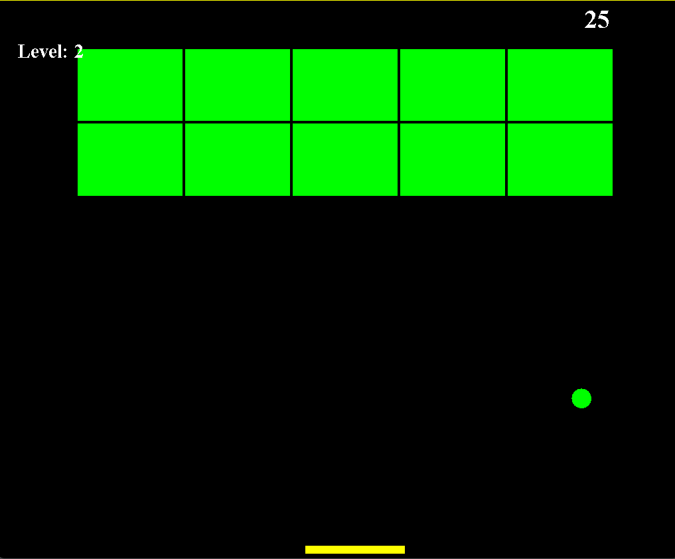

Fig. 5.1- level 2 output

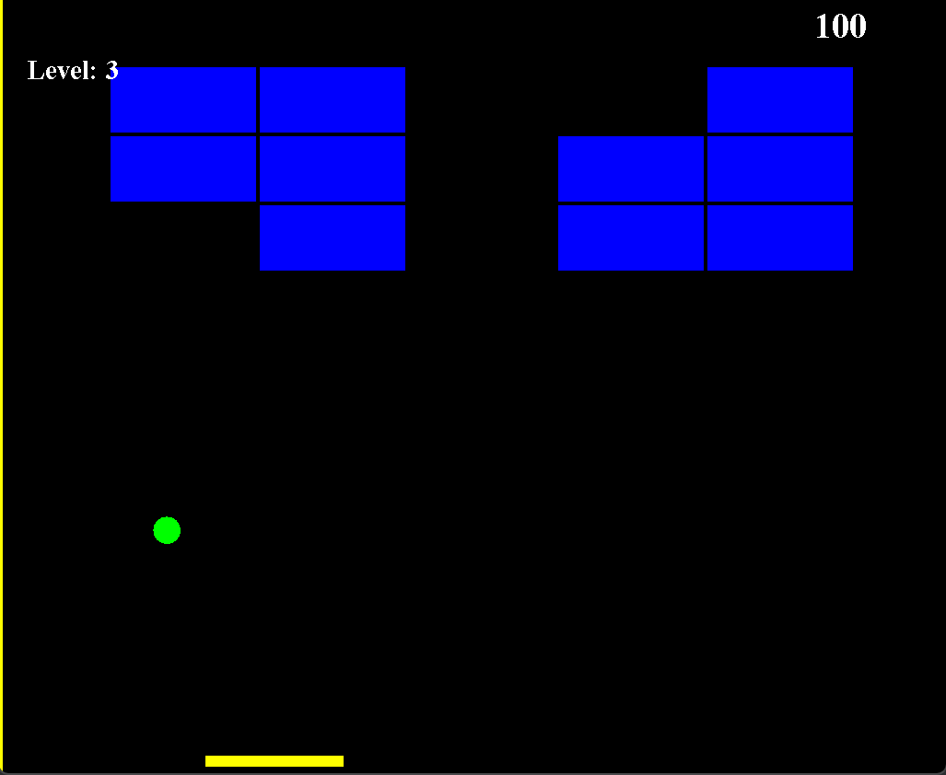

Fig. 5.2 – level 3 output

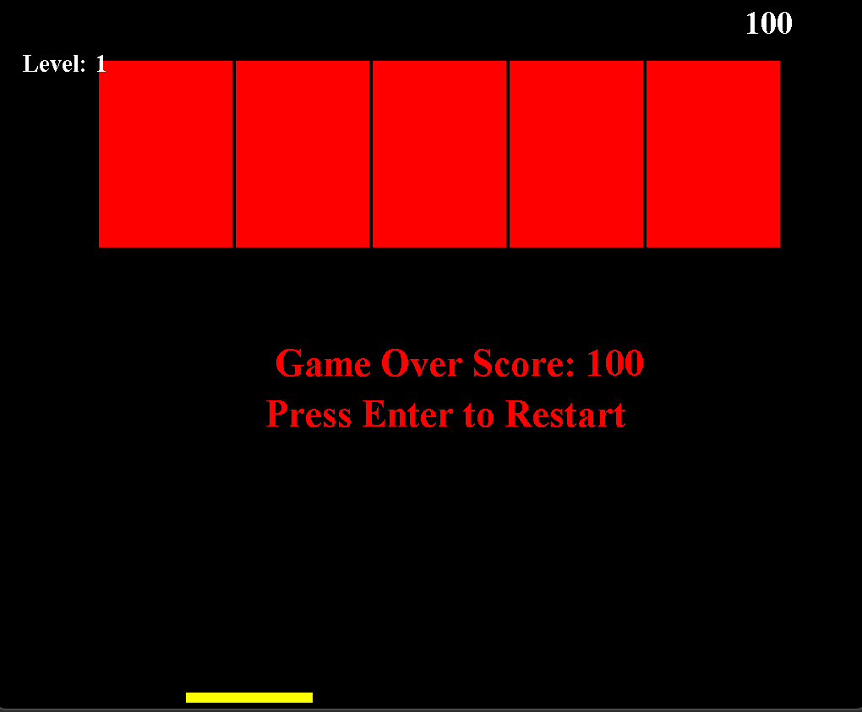

Fig. 5.3 – Game Over Display

# CHAPTER ⅤI

## CONCLUSION AND SCOPE OF FURTHER WORK

#### Conclusion:

The development of the Block Smasher game in Java has resulted in a functional and entertaining gaming experience, offering players an engaging opportunity to test their reflexes and strategic skills. The implemented features, including responsive player control, accurate collision detection, and an effective scoring system, have contributed to the creation of a stable and enjoyable gameplay environment.

#### Future Scope:

* Advanced Gameplay Mechanics:

To enhance the gaming experience, future iterations of the game can introduce more advanced gameplay mechanics, such as dynamic level progression, boss battles, and intricate block patterns that require precise ball maneuvering.

* Enhanced Visual and Audio Elements:

Implementing high-quality visual effects, animations, and immersive sound effects can significantly improve the overall appeal and engagement of the game, creating a more captivating and immersive environment for players.

* Customization and Personalization:

Introducing customization options for paddle designs, ball types, and background themes can allow players to personalize their gaming experience, fostering a sense of ownership and attachment to the game.

* Integration of Online Features:

Incorporating online functionalities, such as global leaderboards, multiplayer modes, and social media integration, can expand the game's reach and foster a vibrant gaming community, encouraging competition and social interaction among players.

* Mobile Adaptation:

Adapting the game for mobile platforms can broaden its accessibility and appeal to a wider audience, enabling players to enjoy the game on the go and fostering a more inclusive gaming experience.

## References

**Online/Website:**

* Java Database Connectivity with MySQL - javatpoint. (n.d.). www.javatpoint.com.https://[www.javatpoint.com/example-to-connect-to-the-mysql-](http://www.javatpoint.com/example-to-connect-to-the-mysql-) database
* JavaFX Documentation Home | JavaFX 2 Tutorials and Documentation. (n.d.).
* https://docs.oracle.com/javafx/2/
* MySQL :: MySQL Connector/J Developer Guide :: 7.1 Connecting to MySQL Using the JDBC DriverManager Interface. (n.d.). https://dev.mysql.com/doc/connector- j/en/connector-jusagenotes-connect-drivermanager.html